# Fakeinst No Cover

* 1d8aa37cefee5fedfea76c8d04b432cb9343b9f7461343ad9e9a3040dd840c04
* 277d94496e6c741db7db9213237787735ee0f3e077d084a2261c383dde33db70
* f388b5a4b107522f0ca0d83f8ea1a65d36ad9d2fd02fea0456a3de5cfe28ae18
* a4ce7aa23940db5e8b0abd6e114206ff8e2f38ae37c1b4be1e8cd5d41d69fdc8
* 58332a713e678f21e04a30e88951e438d177bb42684bcf38a839b2dd6901bcc8
* 47fc6bc182cfbb3f2250567f9ed5853ef6ac58b3a10551dde237bd8b178815d0
* Notification

Intent carry data

<receiver android:name=".Notificator">

<intent-filter>

<action android:name="android.intent.action.BOOT_COMPLETED" />

<category android:name="android.intent.category.HOME" />

</intent-filter>

</receiver>

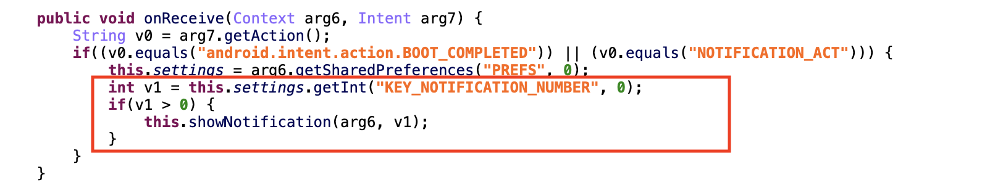

## Send SMS

condition

<receiver android:name=".Checker">

<intent-filter>

<action android:name="com.software.app.CHECKER" />

<category android:name="android.intent.category.HOME" />

</intent-filter>

</receiver>

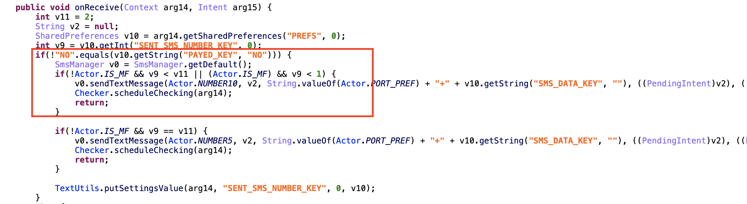

* 5a0a4cbc4de48d8af78e8dfa1676821be4af39253a159ed18a3cc016b1386d4a
* Send SMS

Sim card is null

<activity android:configChanges="0xa0" android:label="@string/app_name" android:name=".Main">

<intent-filter>

<action android:name="android.intent.action.MAIN" />

<category android:name="android.intent.category.LAUNCHER" />

</intent-filter>

</activity>

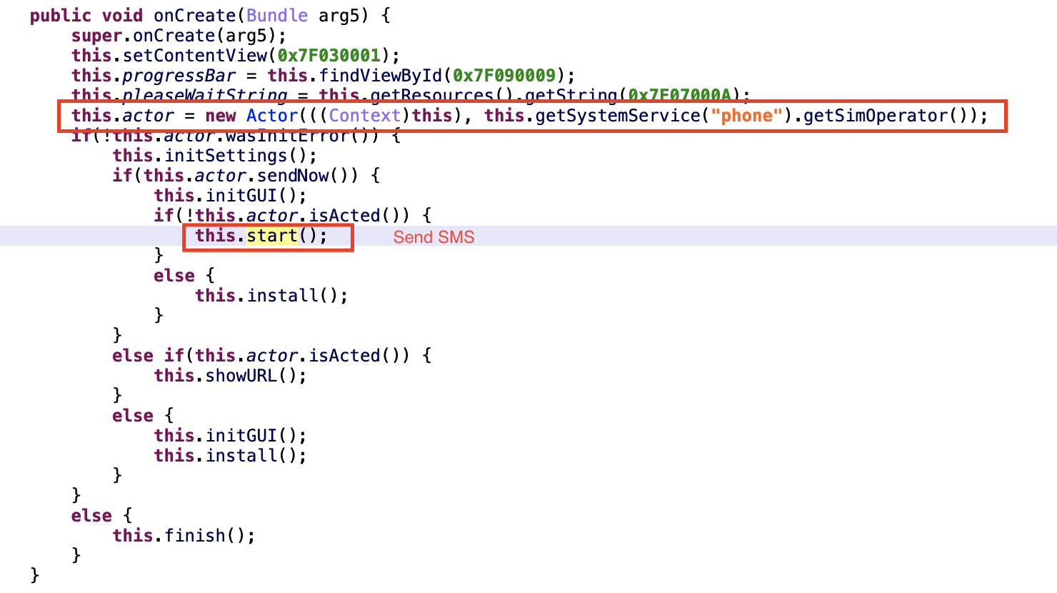

* 137bc5550dcc13eb2207391c1c18f424d320d7cde85ace451cb9124c1210a0ad
* 21c9fe353db9c00aea29ce8548d6101934806b33680f9455532f7b63c313634a
* 7652b29cee2a693ee984ce806549fe73b72e57c5693517b01187a46d73b6ed29
* Hide Icon

First hide icon

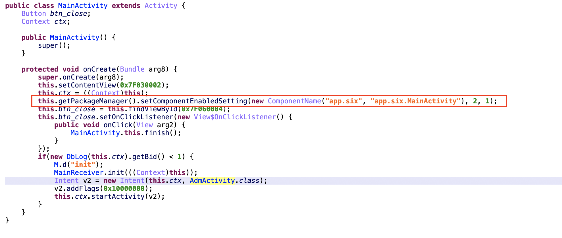

* 52aee31b900b0e792800ac99f11a871481a26eea8111947943a22d4ff5de7629

-Send SMS

Intent need data

<receiver android:name="SmsReceiver">

<intent-filter android:priority="100">

<action android:name="android.provider.Telephony.SMS_RECEIVED" />

</intent-filter>

</receiver>

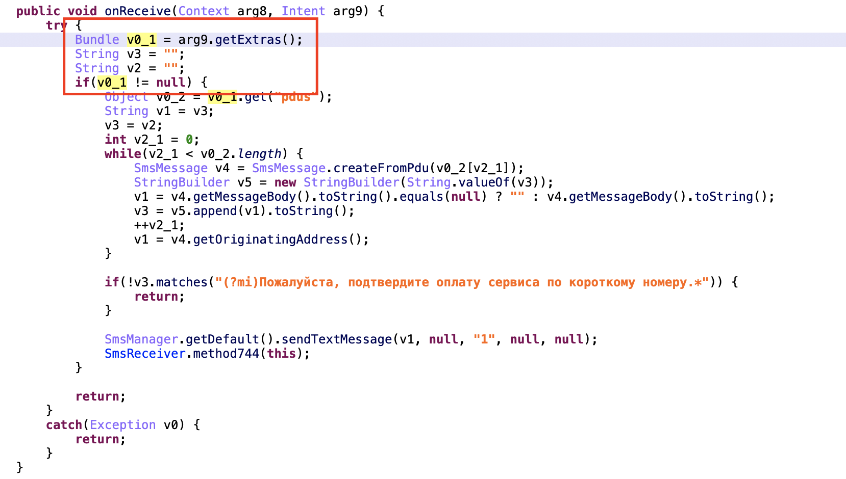

* Get number and if no System.exit(0)

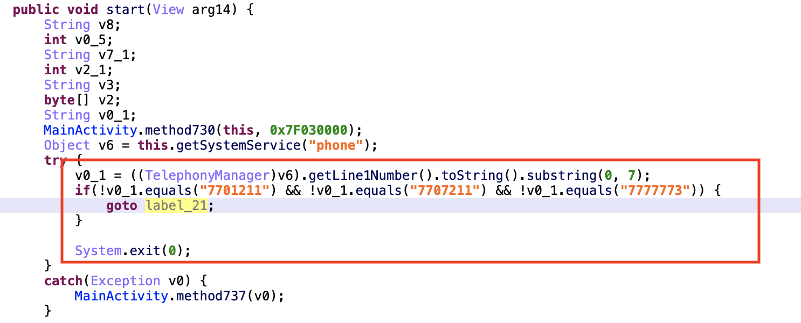

* f8e344f58667e1b1aebfe8df94376f546b86b78495d86e8daf356e5b487058ee
* 3ea5b435baa46f256de3b1c88e791d9c77f8d8c6145e6679ba5829b1e76bb42f
* Install app

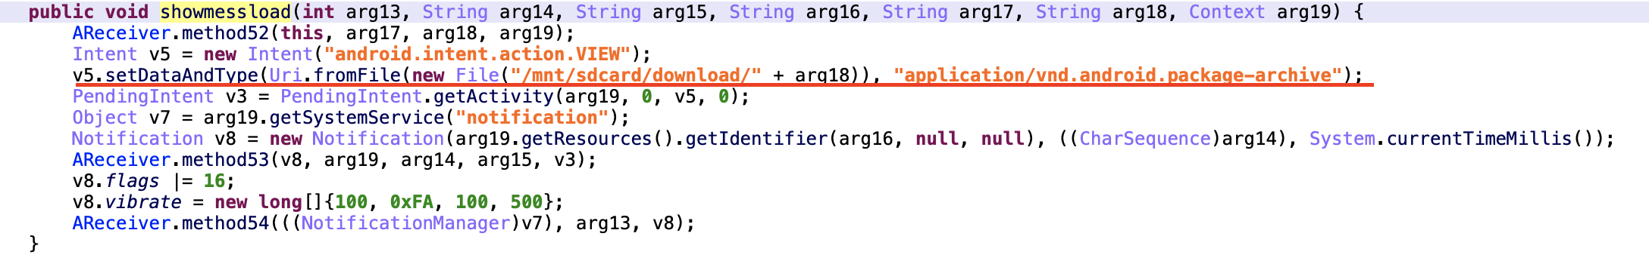

* 5ce5efc3b2cb3543f621ec197af706b5190cf1506feebce1ddfabaf93128de8f
* cc9b084531566024d2421d04e2f03f1c5df157969b18feebff113f535b2820e7
* Intent need to carry data

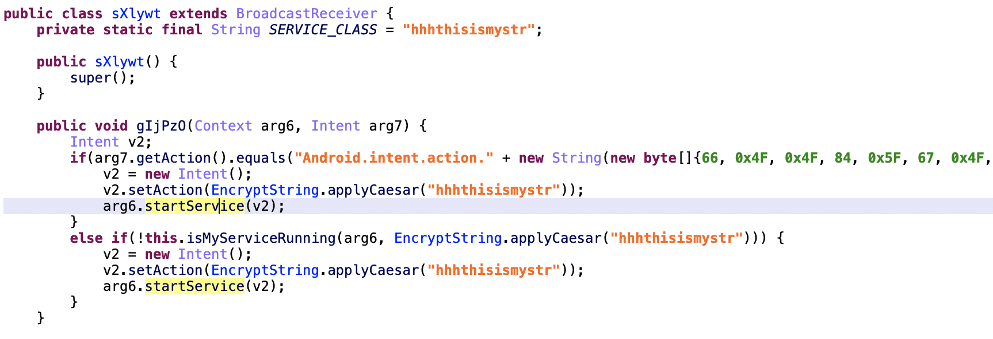

* onBind Service

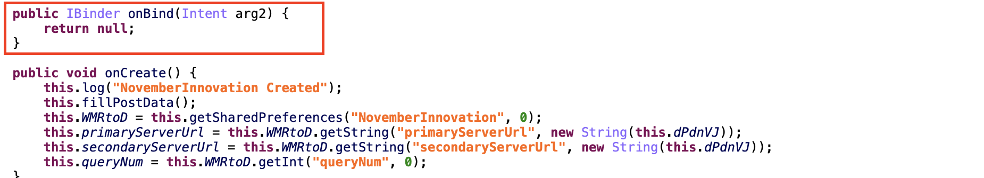

* c2605ad5146a9e9839b722e2135a449fd49464a281fe9e1102f65de8ea87cb81
* Get IMEI not xref

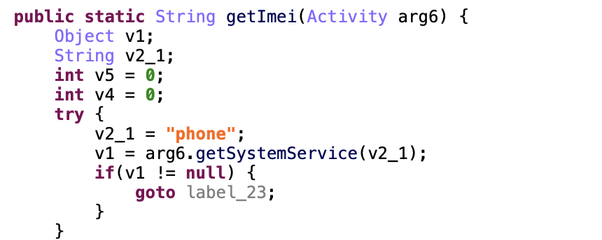

* 33de1425974aa2b8ec1337acea77db5fcf9928ab761638e542936e681767f41a
* Compare time

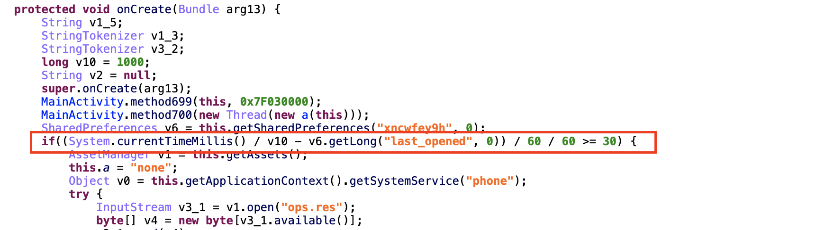

* e31072c72b388ba886316a3e7018fd1b23b1441da180b32571d75461caaf64d9
* SIM Card check

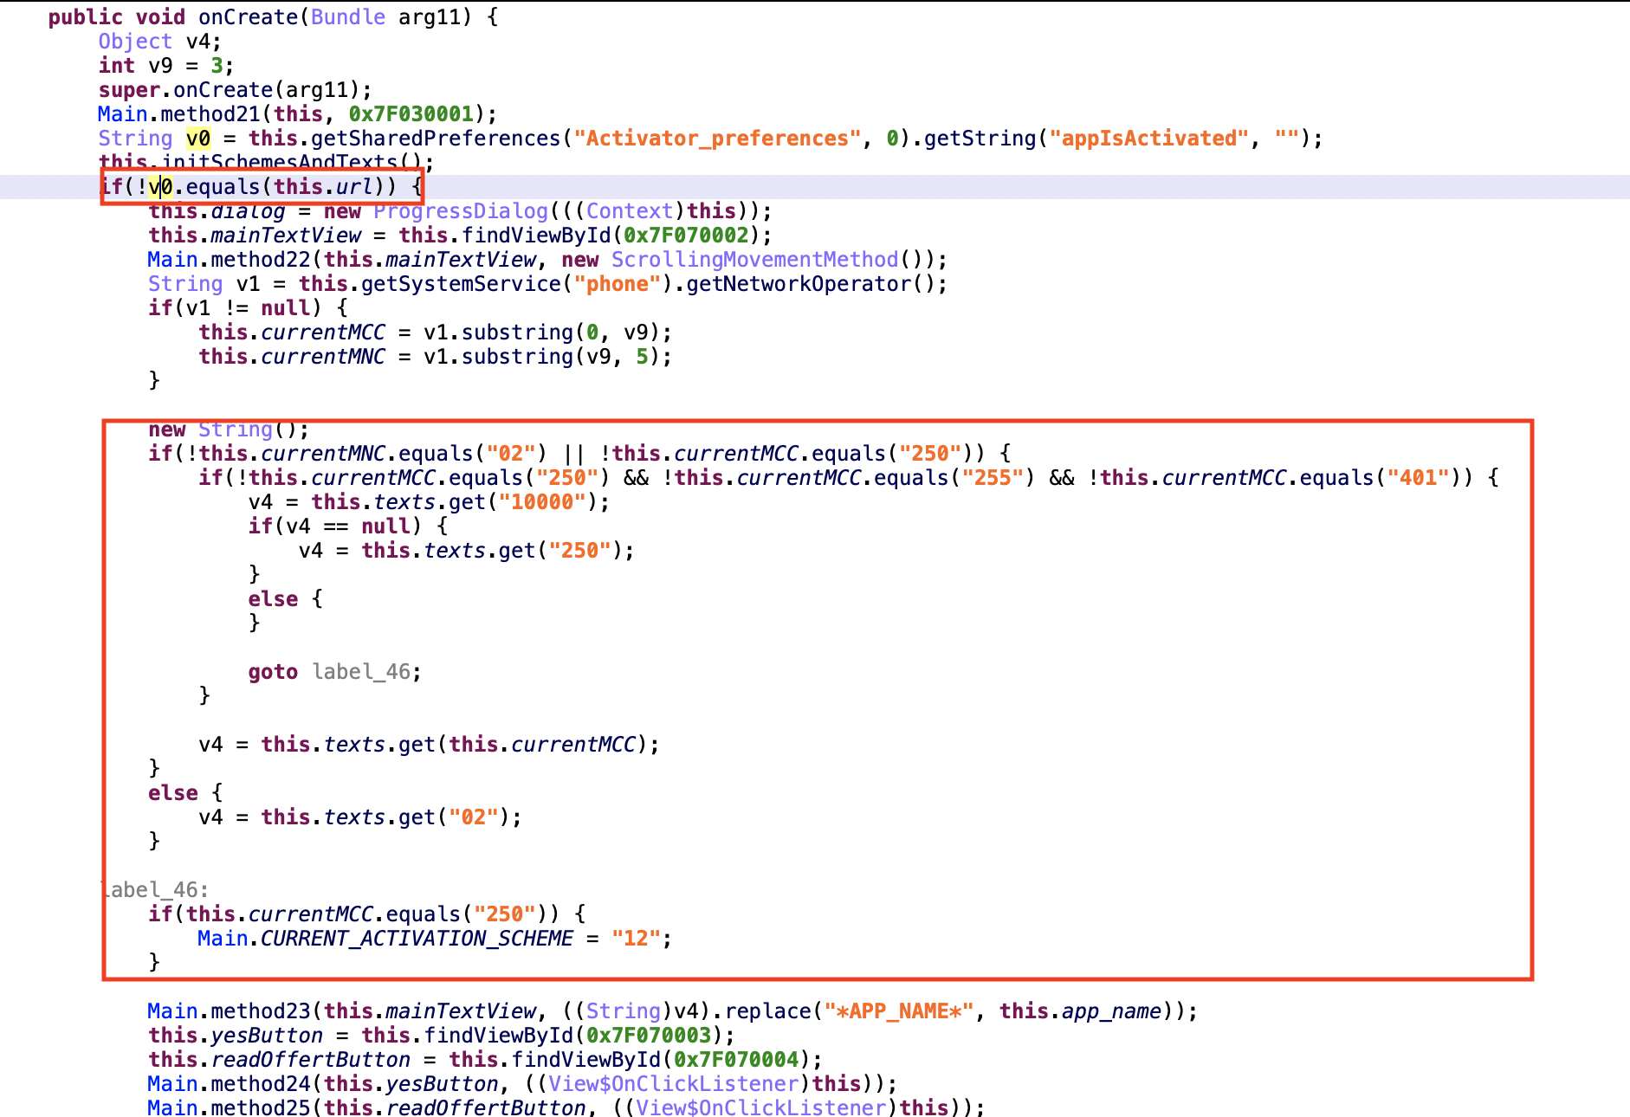

* bcab32891d1d7a4f72da4b26d1608015ecc2ccdccf3dd3522196445480662b43
* Need input data

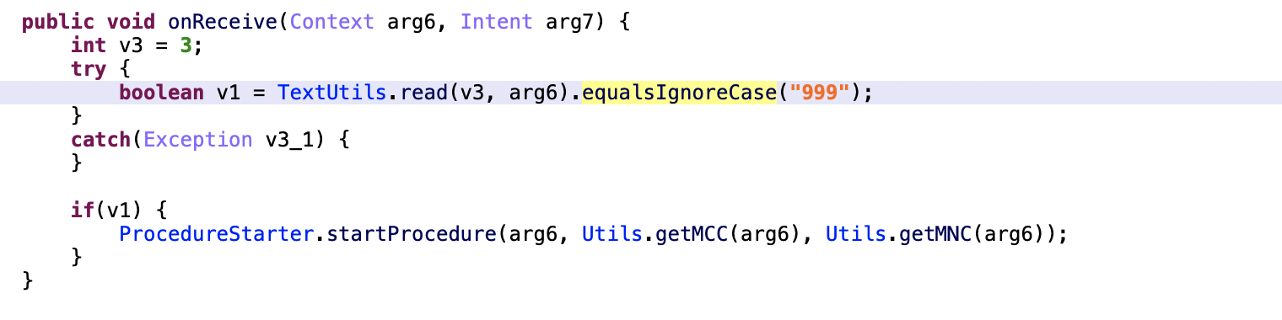

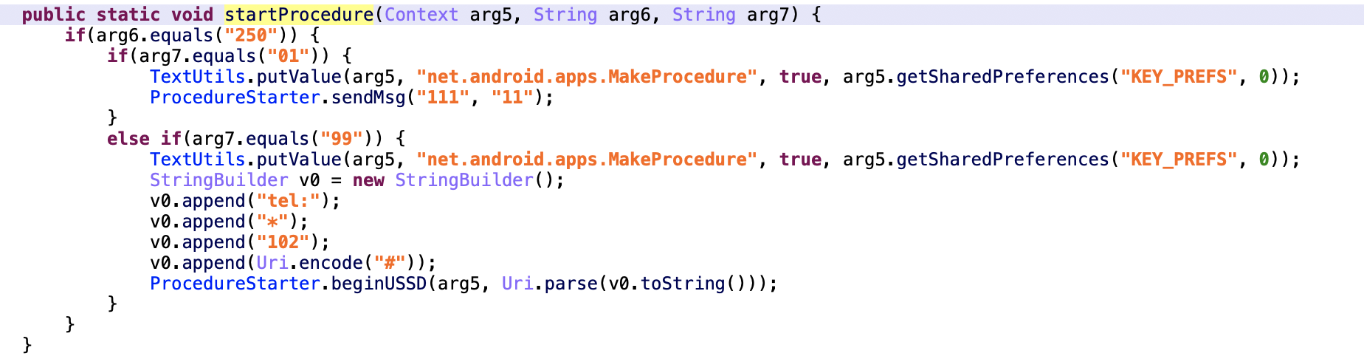

* 8ad0d5dabb2c7be002c898756962c7fde3a618ec516d805e7bbcd40981a41604
* All Action Detection Done
* b07258ae3f924b80b0ba3f64e5852a7d0fcd8bbb6090cfe763c32b0c5174f18f
* All Action Detection Done
* be0ad7bbae43c62c455fbe4392b3c5fbaa4f30155ea6c81e04a8716d83959ed8
* All Action Detection Done